


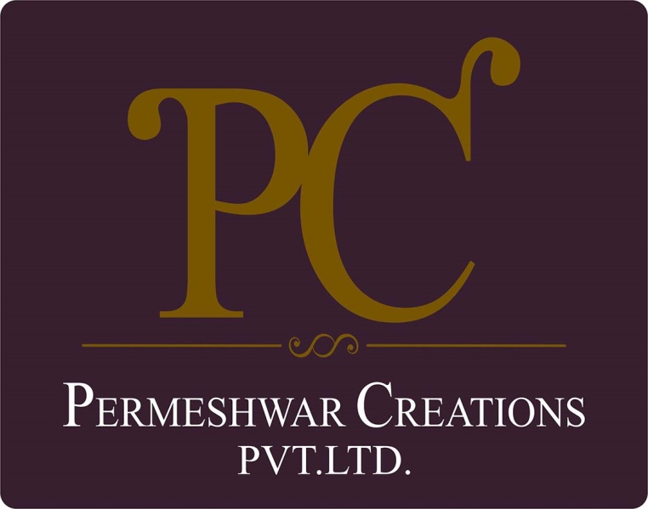

POLICY ON EQUAL OPPORTUNITY

With effective from: 01/04/2023
Revision: 01
Last review date: 01/01/2024
Next review date: 01/01/2025

TABLE OF CONTENTS

Introduction 3
Scope 3
Policy Statement 3
Our Vision 3
SDGs Covered 4
Responsibility 5
Review Mechanism 5
Acknowledgement 5

Introduction
Permeshwar Creations is a renowned apparel manufacturing company in India, known for its commitment to quality, innovation, and sustainability. At Permeshwar Creations, we pride ourselves on being a leader in the apparel manufacturing industry. Since our inception, we have been dedicated to producing high-quality garments that meet the needs of our diverse clientele. Our research and development team continuously innovate, creating lightweight, fine-textured garments in a variety of beautiful colors and designs.

Scope
This policy covers all aspects of Permeshwar Creation’s operations, including manufacturing, transportation, and product lifecycle management. It applies to all workers, employees, suppliers, and stakeholders involved in our operations. This policy applies to below mentioned locations:
Address | PK  Enterprises | C-19, Hoisery Complex, Phase II, Noida, U.P- 201301.India
Address | Rishita Fashion | Plot no. 1102, Phase III, GIDC,  Vapi, Valsad, Gujrat- 396195

Policy Statement
Permeshwar Creations is committed to conducting business ethically and with integrity. We strive to prevent any form of corruption and ensure responsible management of information.

Our Vision
Below are our commitments and targets towards equal opportunity as compared to baseline year 2022.

- Workplace Safety and Health
- Ensure safety at work through comprehensive safety protocols.
- Promote physical and psychological health at work.
- Implement stress prevention measures.
- Achieve a 20% reduction in workplace accidents by 2025.
- Work-Life Balance and Well-being
- Support work-life balance initiatives.
- Respect the right to disconnect after work hours.
- Regularly conduct employee satisfaction surveys.
- Provide competitive remuneration and social benefits.
- Increase overall employee satisfaction by 15% based on annual surveys.

- Employee Engagement and Communication
- Foster structured social dialogue through recognized employee representatives.
- Support collective bargaining processes.
- Conduct biannual meetings with employee representatives with an attendance rate of 90%.
- Career Development and Advancement
- Ensure fair recruitment, evaluation, and promotion processes.
- Facilitate training and career development opportunities for all employees.
- Increase employee participation in professional development programs by 15% annually.
- Labor Rights Compliance
- Prohibit child labor, forced labor, and human trafficking in all company operations.
- 0% tolerance for any incidents related to child labor, forced labor, or human trafficking.
- Diversity, Inclusion, and Equal Opportunities
- Prevent discrimination, harassment, and abuse in the workplace.
- Promote equal treatment and opportunities for employees from diverse backgrounds.
- Increase diversity in leadership roles by 25% by 2025.
- Ethical Supply Chain Practices
- Ensure suppliers adhere to ethical labor practices and human rights standards.
- Conduct regular audits and assessments of supply chain partners.
- Achieve 100% compliance with ethical supply chain standards by 2025.
- Community Engagement and Social Impact
- Support local communities through sustainable initiatives.
- Mitigate negative social impacts of business operations.
- Increase community engagement projects by 20% annually.

SDGs Covered
This policy aligns with the United Nations Sustainable Development Goals (SDGs), particularly:

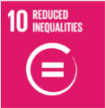

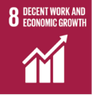



Responsibility
The responsibility for implementing and upholding this ethics policy lies with every employee, director, officer, contractor, and agent of Permeshwar Creations. Senior management, led by the Human Resource Manager (HR), will oversee policy execution and provide necessary resources for successful implementation.

Review Mechanism
This policy will undergo annual reviews overseen by the Chief Human Resources Officer, with the next review scheduled for 1st January 2025. Updates or amendments will be communicated to all stakeholders accordingly. Regular audits and reporting will ensure ongoing compliance with the policy's objectives and principles.

Acknowledgement
I, Gladys Coutinho, acknowledge that I have read and understood this, Policy. I commit to upholding the principles outlined therein, including preventing corruption, ensuring responsible information management, promoting environmental sustainability, upholding supplier ethics, fostering a safe and inclusive workplace, and contributing positively to the Sustainable Development Goals (SDGs). I understand that compliance with this policy is a fundamental expectation and a condition of my employment with Permeshwar Creations.

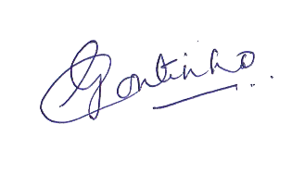
Employee Name: Gladys Coutinho

Employee Signature:

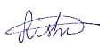

Approved by: Rishidev Gyandev Sadh
Designation: General Manager of Operations
Date: 07.01.2024

